Xxx …………….Task on VPC ………………….. xxX

- Create VPC with 2 private and 2 public subnets.

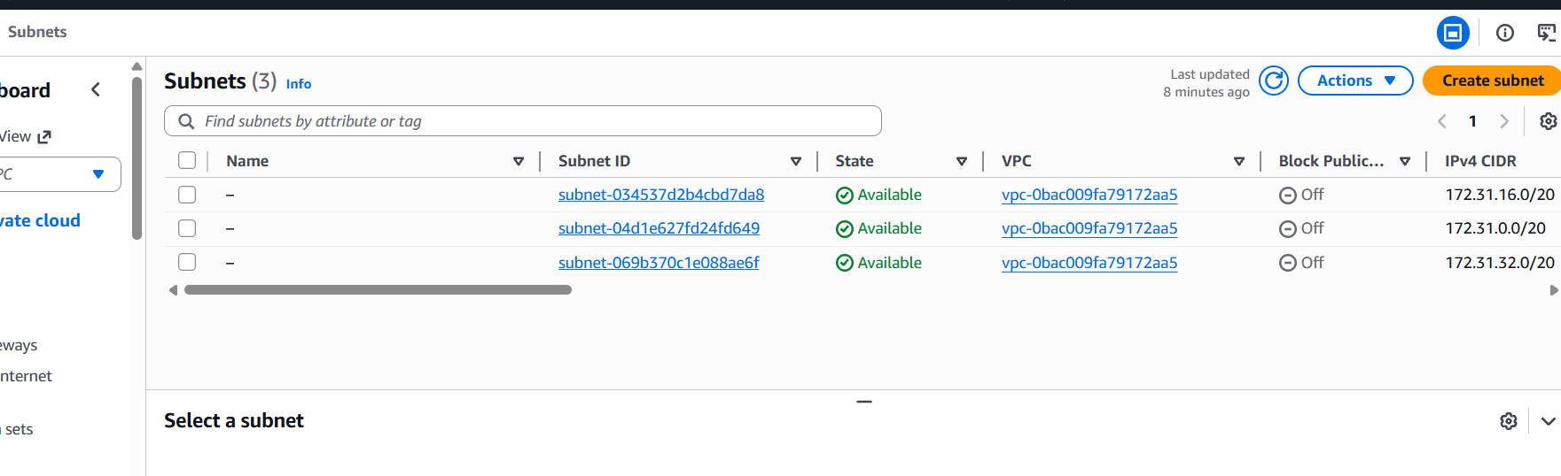

- Enable DNS Hostname in VPC.

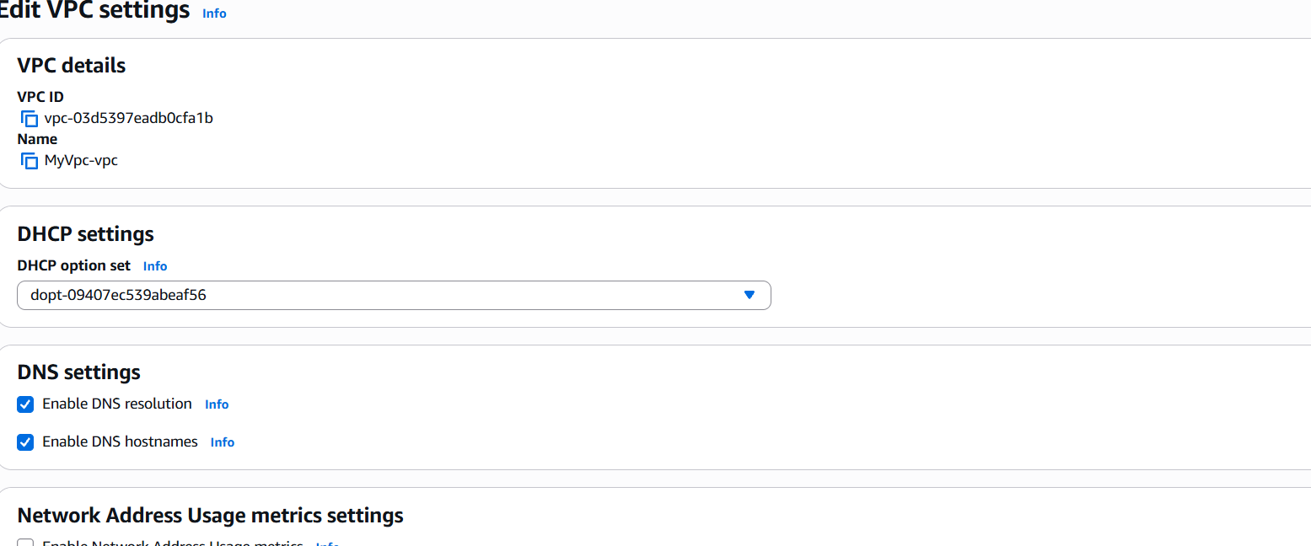

3 ) Enable Auto Assign Public IP in 2 public subnets.

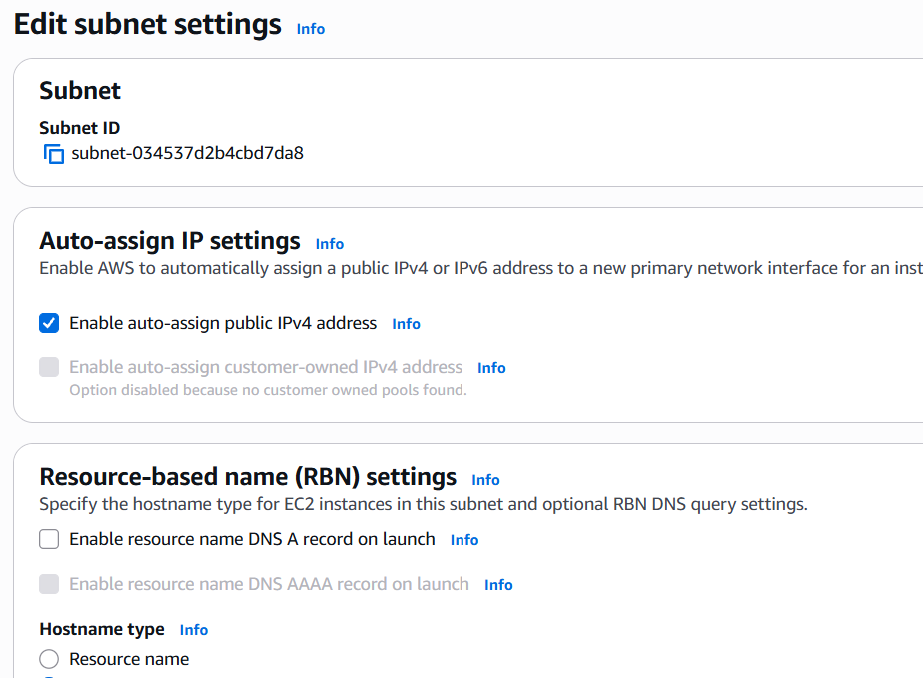

Enabling another public subnet

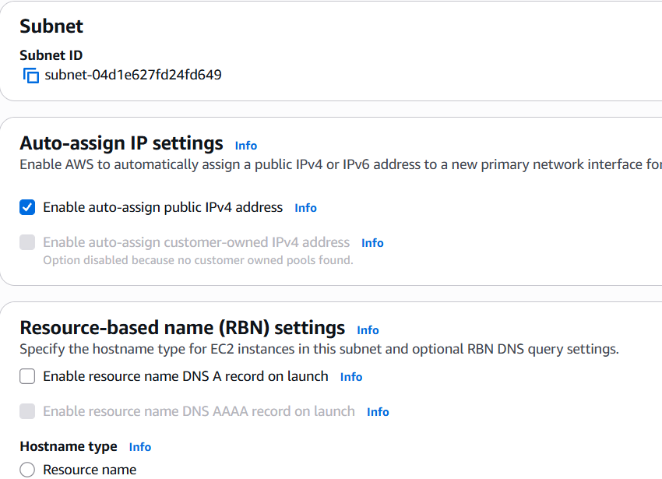

- Add 2 private subnets in private route table

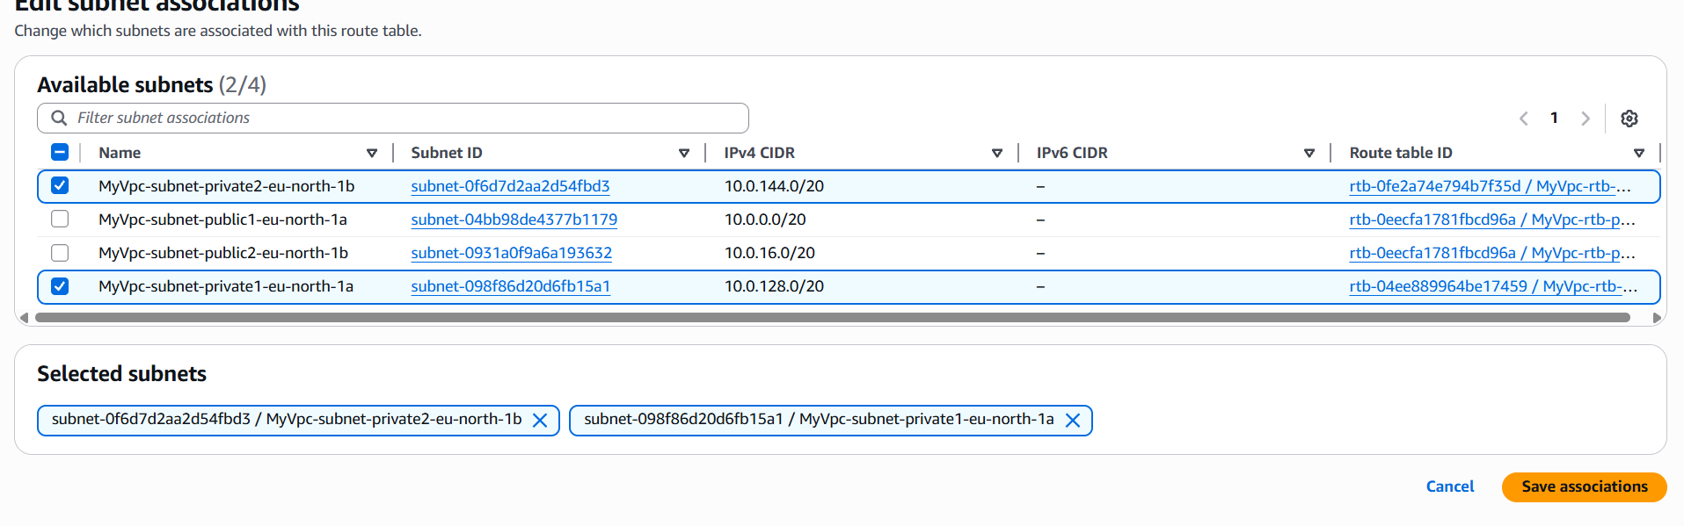

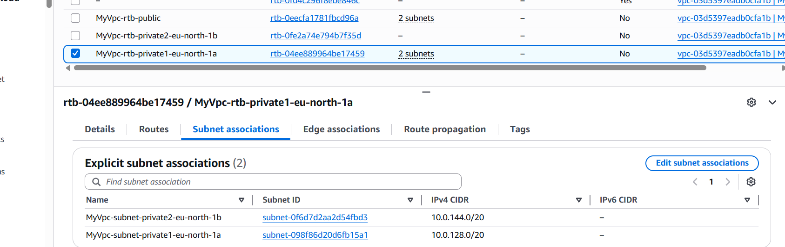

- Add 2 public subnets in public route table.

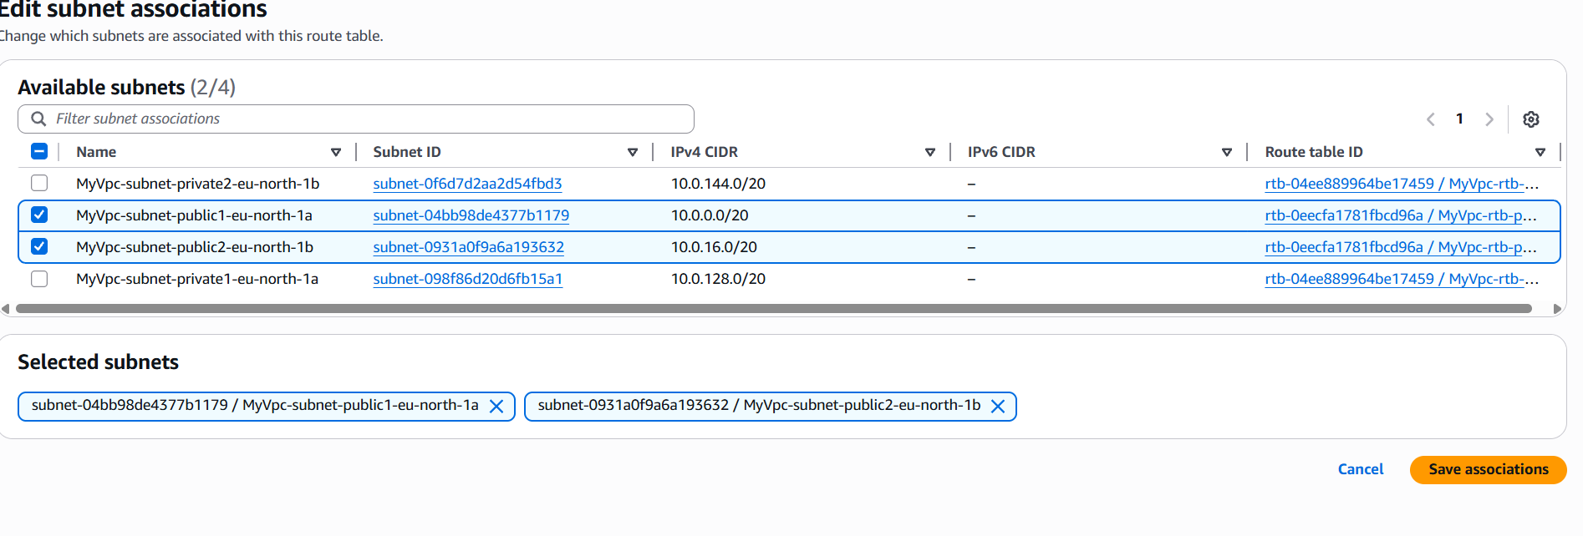
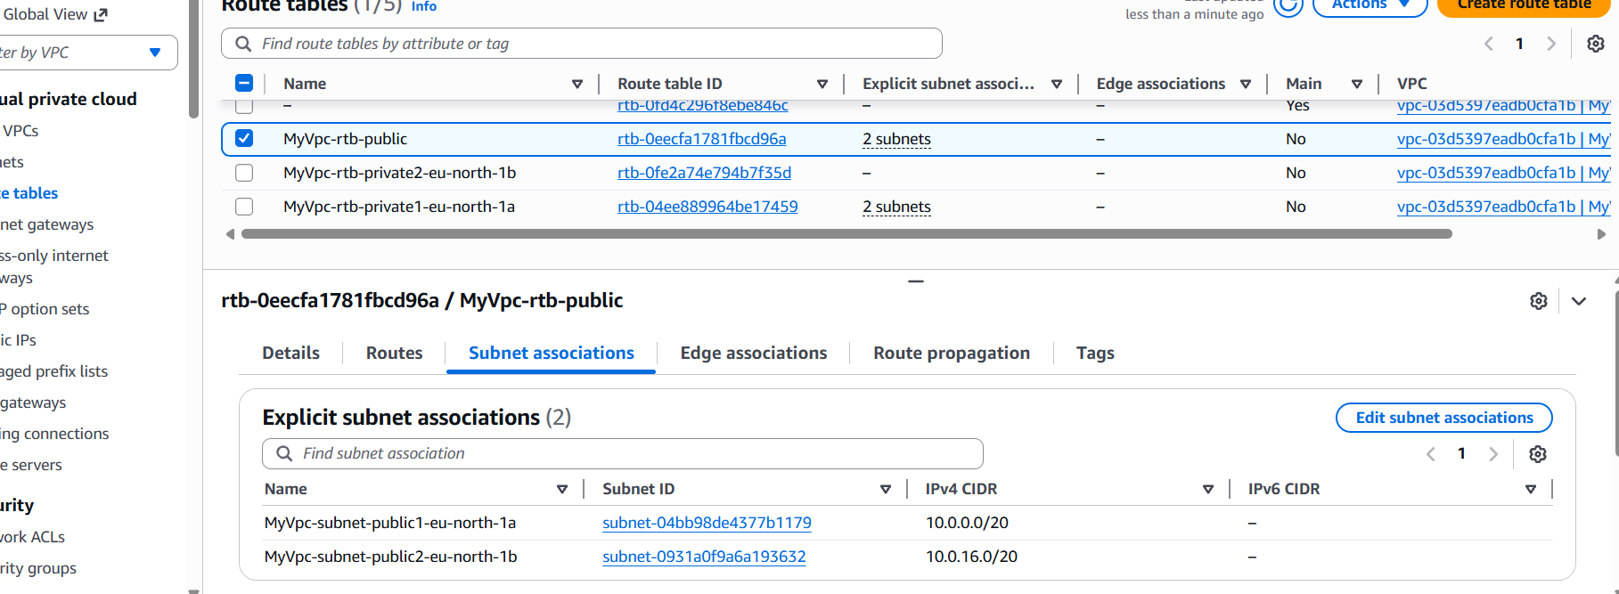

6.Public route table will have the routes to internet and local.

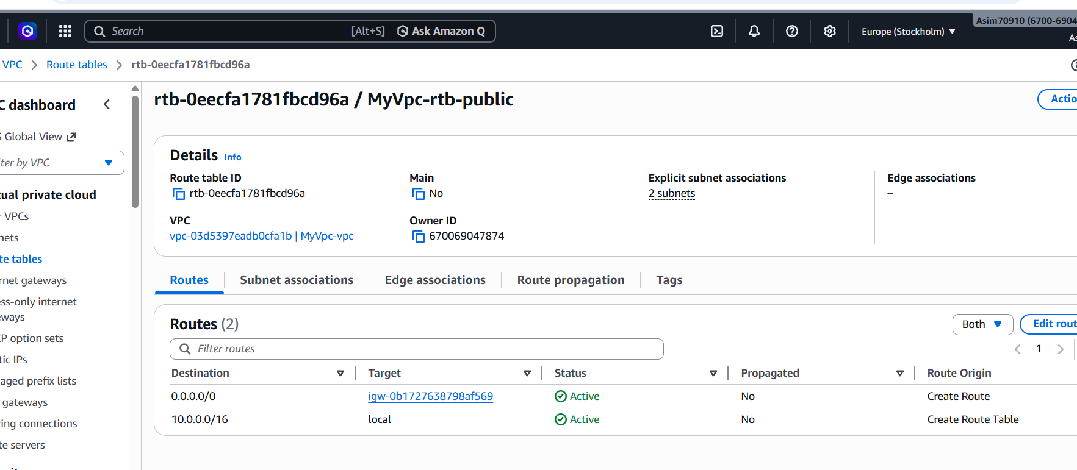

- Create EC2 in public subnet with t2.micro and install PHP.

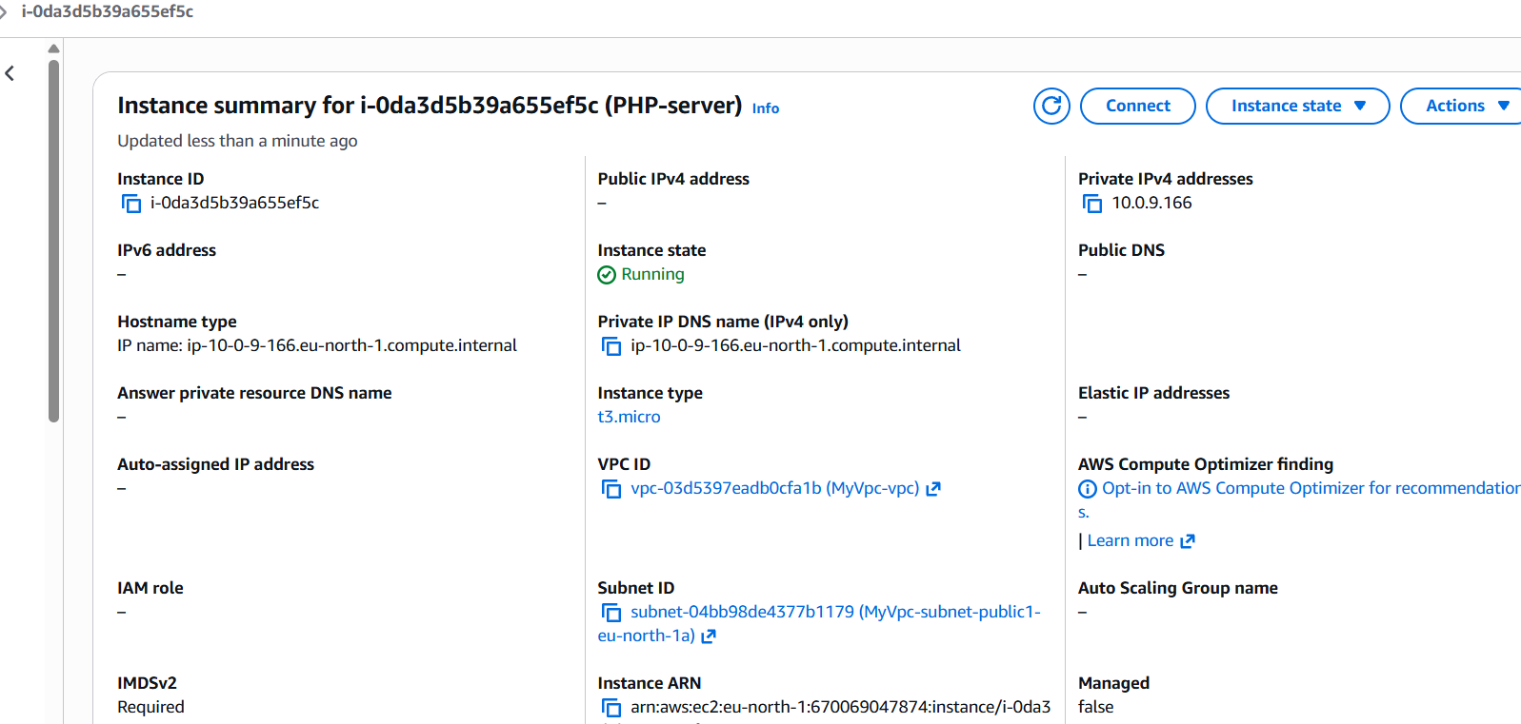

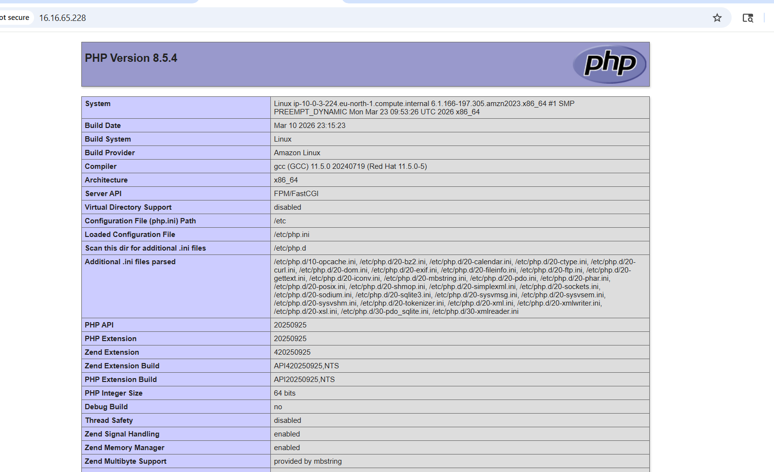

- Configure NAT gateway in public subnet and connect to private instance
